EXP-1
AIM:
To develop a predictive text system using NGram and HMM (Hidden Markov Models) to predict the next word based on previous context.
- NGram Model:
Program:
import nltk
import re
from nltk.corpus import brown
from nltk.tokenize import word_tokenize
from nltk.util import ngrams
from collections import Counter

nltk.download('brown')
nltk.download('punkt')
nltk.download('punkt_tab')

sentences = brown.sents()
text = " ".join([" ".join(sent) for sent in sentences])

text = text.lower()
text = re.sub(r'[^a-z\s]', '', text)
tokens = word_tokenize(text)
tokens = [t for t in tokens if t.strip() != ""]

unigrams = list(ngrams(tokens, 1))
bigrams = list(ngrams(tokens, 2))

unigram_freq = Counter(unigrams)
bigram_freq = Counter(bigrams)

vocab_size = len(set(tokens))

def predict_next_word_ngram(word):
word = word.lower()

candidates = {
w2: count
for (w1, w2), count in bigram_freq.items()
if w1 == word
}

if not candidates:
return "No prediction available"

probs = {
w: (count + 1) / (unigram_freq[(word,)] + vocab_size)
for w, count in candidates.items()
}

return max(probs, key=probs.get)
user_word = input("Enter a word (N-Gram): ")
print("Predicted next word:", predict_next_word_ngram(user_word))

Output:
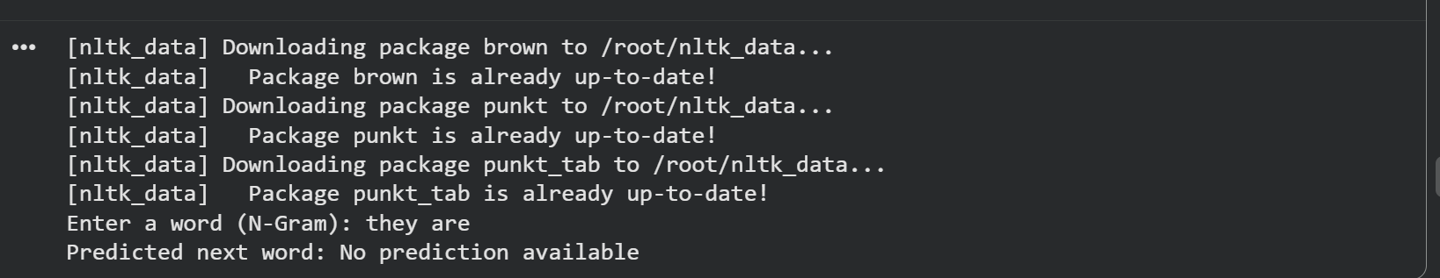

- HMM (Hidden Markov Models)
Program:
import nltk
import random
from nltk.corpus import brown
from nltk.tag import hmm

nltk.download('brown')
nltk.download('universal_tagset')

tagged_sentences = brown.tagged_sents(tagset='universal')

trainer = hmm.HiddenMarkovModelTrainer()
hmm_model = trainer.train(list(tagged_sentences[:5000]))

def predict_next_word_hmm(sentence):
words = sentence.lower().split()
tagged = hmm_model.tag(words)

last_tag = tagged[-1][1]

next_tag = max(
hmm_model._states,
key=lambda tag: hmm_model._transitions[last_tag].prob(tag)
)

word_probs = {
word: hmm_model._outputs[next_tag].prob(word)
for word in hmm_model._outputs[next_tag].samples()
}

top_words = sorted(
word_probs.items(),
key=lambda x: x[1],
reverse=True
)[:5]

return random.choice(top_words)[0]

user_sentence = input("Enter a sentence (HMM): ")
print("Predicted next word:", predict_next_word_hmm(user_sentence))

Output:
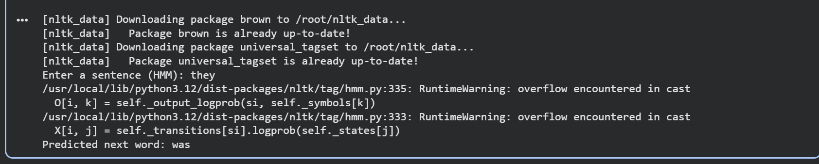

Result:
Thus we successfully developed a predictive text system using N-Gram and HMM (Hidden Markov Models) to predict the next word based on previous context.

